
SOC Alert Management and Incident Response Report
Submitted BY:
B.PRANEETH
Date:
13 May 2026

INTRODUCTION:
This practical task was performed to understand the basic workflow followed in a Security Operations Center (SOC). Different activities related to alert classification, incident handling, alert triage, and investigation documentation were completed during this task. The practical work helped in understanding how SOC analysts monitor suspicious activities, classify alerts based on severity, and document incidents during investigations.

Objectives:
- To understand SOC alert classification
- To learn alert prioritization methods
- To practice incident documentation
- To understand investigation workflow
- To learn basic SOC monitoring activities

Tools Used:
- Kali Linux
- Microsoft Word
- SSH Command
- GitHub


ENVIRONMENT SETUP:
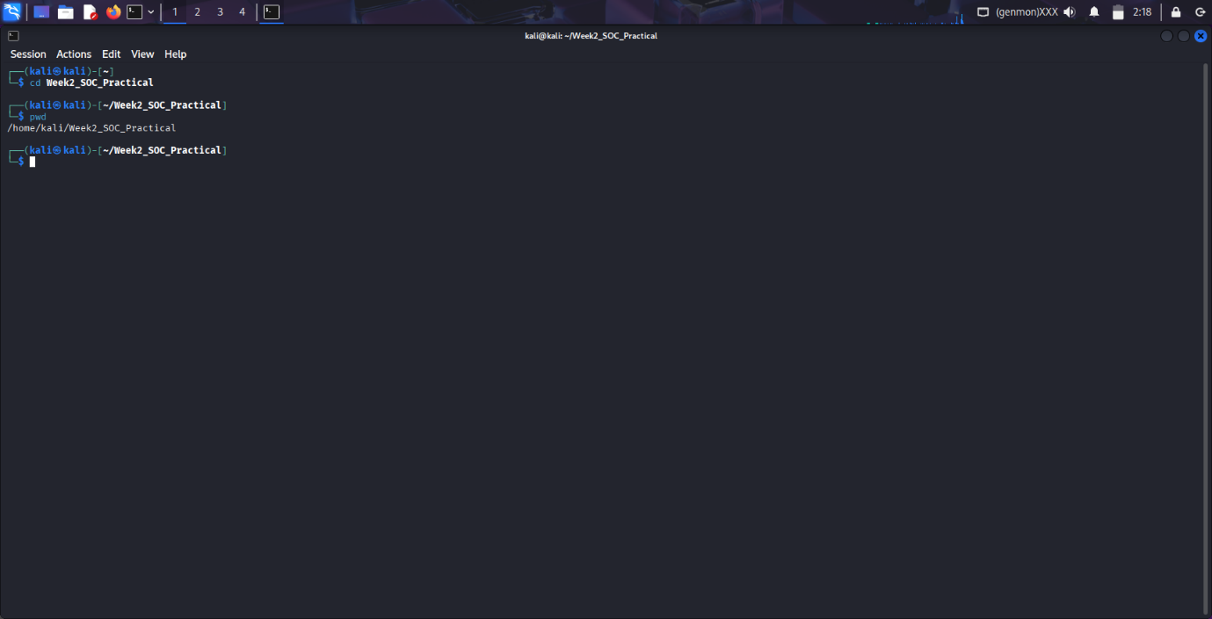
Explanation:
The environment setup process was completed in Kali Linux by creating and verifying a dedicated working directory for the SOC practical task. Terminal commands such as cd and pwd were used to confirm the correct directory location before starting the practical activities. This working environment helped organize screenshots, documentation files, and workflow-related content in a structured manner throughout the task. Maintaining a separate directory also improved file management and made the overall documentation process easier during the SOC practical implementation.





Failed SSH Login Attempt:
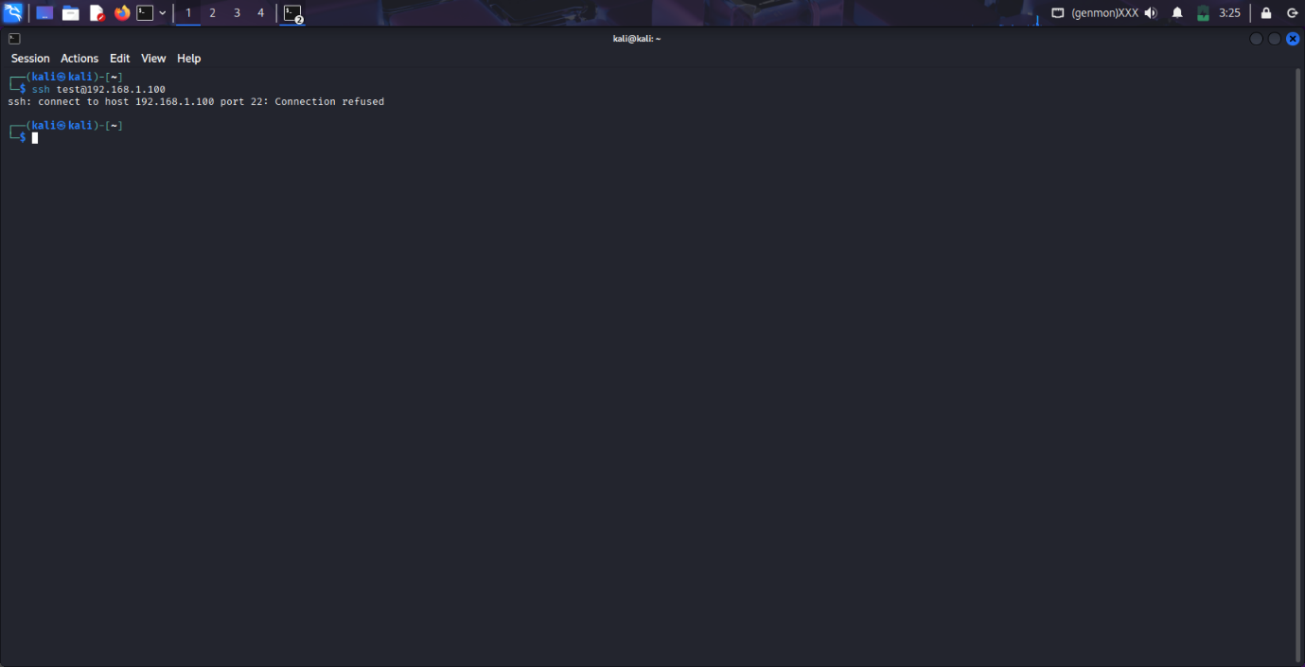
Explanation:
A failed SSH login attempt was simulated using the SSH command in Kali Linux to understand how unauthorized access attempts may appear during SOC monitoring activities. During the connection process, the target system rejected the request and displayed a “Connection Refused” message. This practical activity helped in understanding how failed authentication attempts can generate alerts and suspicious login events in security monitoring environments. The exercise also provided basic knowledge about SSH-related alert analysis and incident investigation procedures followed in SOC operations.



Alert Classification Table:
Alert ID | Alert Type | Priority | MITRE Technique
001 | Phishing Email | High | T1566
002 | Brute-force SSH | Medium | T1110
003 | Port Scan | Low | T1046

Explanation:
The alert classification table was created to understand how SOC analysts categorize different security alerts based on severity and attack type. Alerts such as phishing emails, brute-force SSH attempts, and port scanning activities were assigned different priority levels according to their potential impact on the system. MITRE ATT&CK techniques were also mapped to understand attack classification methods used in SOC operations.



Incident Ticket:
Incident Title:
Brute-force SSH Attempt
Description:
Multiple failed SSH login attempts were detected from source IP 192.168.1.100.
Priority:
Medium
Assigned To:
SOC Analyst
This incident was classified as a medium priority alert because repeated failed login attempts may indicate suspicious or unauthorized access activity.

Explanation:
An incident ticket was created to document the failed SSH login activity detected during monitoring. The ticket included details such as incident title, description, priority level, and assigned analyst information. Incident tickets help SOC teams track and manage suspicious activities in an organized manner during investigations.



Investigation Steps:
Timestamp | Action
10:00 AM | Detected failed SSH attempts
10:10 AM | Checked source IP
10:20 AM | Monitored network traffic
10:30 AM | Documented the incident

Explanation:

The investigation process was documented step-by-step to record the activities performed during alert analysis and monitoring. Different actions such as detecting failed login attempts, checking source IP addresses, monitoring traffic activity, and documenting the incident were included in the workflow.

Alert Triage Table:
Alert ID | Description | Source IP | Priority | Status
004 | Brute-force SSH | 192.168.1.100 | Medium | Open

Explanation:
The alert triage table was created to understand how SOC analysts prioritize and manage alerts based on severity and suspicious activity. Important information such as alert description, source IP address, priority level, and alert status was documented as part of the triage process.



Alert Priority Levels:
Alert | CVSS Score | Priority
Log4shell | 9.8 | Critical
Phishing Email | 7.5 | High
Port Scan | 3.0 | Low

Explanation:
The alert priority level table was created to understand how different security incidents are categorized using CVSS scores and severity levels. Critical threats such as Log4Shell vulnerabilities were assigned higher priority compared to lower-risk activities like port scanning. Proper prioritization helps SOC teams respond quickly to serious security incidents.

Phishing Investigation Checklist
☑ Verify email headers
☑ Check suspicious links
☑ Identify affected users
☑ Scan attachments
☑ Report suspicious activity
Explanation:
The phishing investigation checklist was prepared to understand the standard verification process followed during phishing email analysis. Different validation steps such as checking sender details, suspicious links, and email attachments were included as part of the investigation workflow.



Observations:
- Different alert types were classified successfully.
- Failed SSH login activity was simulated and documented.
- Alert triage workflow was understood successfully.
- Incident documentation and investigation procedures were practiced.
- SOC monitoring and prioritization concepts were understood during the task.

Conclusion:
This practical task helped in understanding the basic workflow followed in Security Operations Centers (SOC). Different alert management, incident handling, and investigation activities were documented successfully. The task improved understanding of SOC alert prioritization, incident response workflow, and cybersecurity documentation practices.

